Aberystwyth town – in partnership with Tyfu Aber Grow
Case Study
July 2023
Location: Various sites in Aberystwyth town centre
Project contact: Tyfu Aber (tyfuabergrow@gmail.com)

Background:
These three sites are located across Aberystwyth and are maintained by volunteers from Tyfu Aber Grow (Aber Food Surplus). Trefechan garden is a small space located in the south of the town with the Rheidol river on one side and the main through route to traffic on the others – Aber Food Surplus maintain this space. Maes Gwenfrewi is located in the north of the town and is maintained by the Town Council but the community uses some raised beds for food production. The Tesco planters are around the carpark of the store, near to Trefechan garden.

How has Tyfi Dyfi and Garden Organic supported the project/site:
The Tyfu Dyfi project has provided £2300 towards materials, plants and seeds across the three sites. The largest number of materials have been used in the Trefechan garden where a new raised bed has been built and benches have been provided. Maes Gwenfrewi and the Tesco planters have benefited from new vegetable plants. The sites feel much more cared for and welcoming than they did before, and it has provided more opportunities for public engagement around food growing in the town.
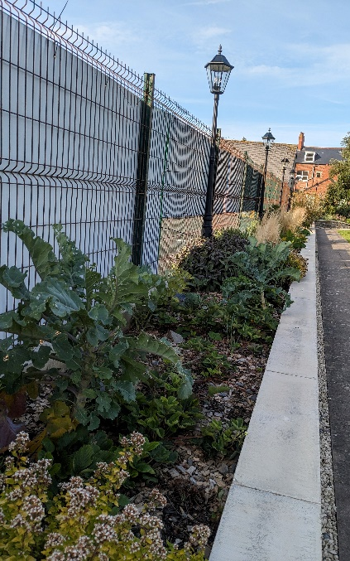
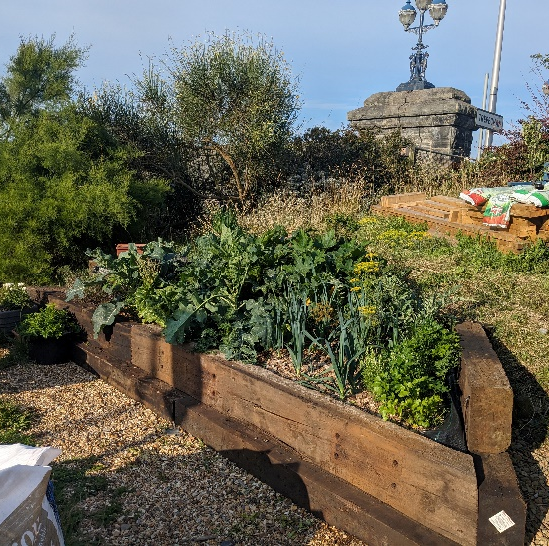
There is now also strong group of core volunteers who look after the growing spaces, some of whom were part of Garden Organic’s Master Gardeners scheme. They are proud of the spaces and have started to develop the sites in more creative ways (i.e. creating innovative water collection systems).
Maes Gwenfrewi
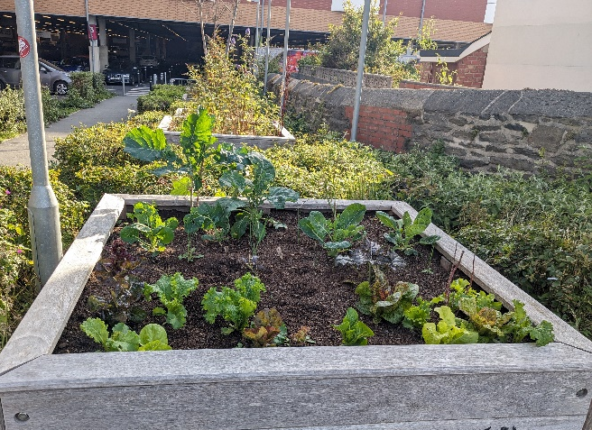
Trefechan Garden
Tesco planters

