Borth Community Gardens
Case Study
July 2023
Location: Borth Community Gardens, Borth, Ceredigion
W3W:

Background:
The gardens have been established since 2010 after a local farmer gave the land to the community. The northern part of the site (closest to St Matthew’s Church) is for allotments which are rented out to locals. The southern half of the site is a community garden. The whole site is open to the public and can be accessed at any time. One of the founding principles of the garden is that there should be no barriers to gardening for anyone, hence the garden has communal tools, sheds and composting area. The gardens have a weekly Cake and Cultivate session which is open to anyone and where it is possible to do some gardening and enjoy some homemade cake afterwards. This session has become a vital link for the local community as a friendly place to come and talk with others.

How has Tyfi Dyfi and Garden Organic supported the project/site:
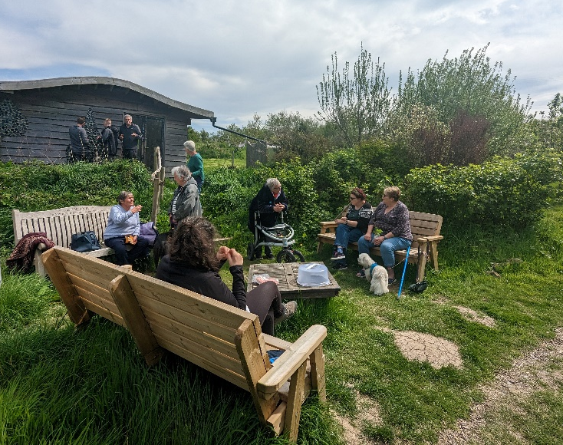
Tyfu Dyfi has provided approximately £3300 worth of funding to the gardens. This included the hiring of skips to help clear rubbish from the site, providing seeds (from the Organic Gardening Catalogue) which the gardens gave out to volunteers and the local community, benches were provided, as well as materials for improving the pathways and the floor of the watershed. The gardens also used some funding to pay for CCTV to be installed at the site following continued acts of vandalism. Without the money from the project, it would have been much more challenging and stressful to solve the vandalism issues.
The project and volunteers feel supported and are very grateful for the funding. This is especially true given the vandalism experiences faced by the gardens throughout 2022/23.

“We would have struggled to raise the funds for the CCTV and stop the vandalism [if it wasn’t for Tyfu Dyfi]”.

