Laudato Si Community Garden
Case Study
July 2023
Location: Welsh Martyrs Church, Piercefield, Aberystywth
W3W: dame.valued.equality
Project contact: Nick Howells

Background:
This is an established community growing site in the grounds of the Church of the Welsh Martyrs in Penparcau. The garden was established in 2018 with the aim of growing food to distribute amongst the community. Up until the funding from Tyfu Dyfi the garden relied on donations of materials to keep going.
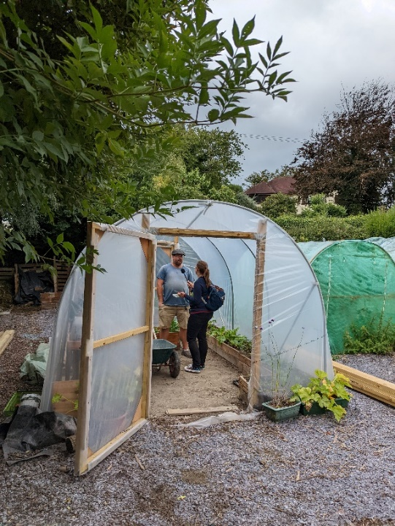
How has Tyfi Dyfi and Garden Organic supported the project/site:
Tyfu Dyfi has provided approximately £3360 worth of materials to the garden. This includes a new polytunnel, raised bed materials, compost and pond materials.
The funding has helped increase the growing space and made the site more accessible to people (better pathways and pond access). The pond area has been improved dramatically, which has led to increased diversity and increased involvement of volunteers in the garden.
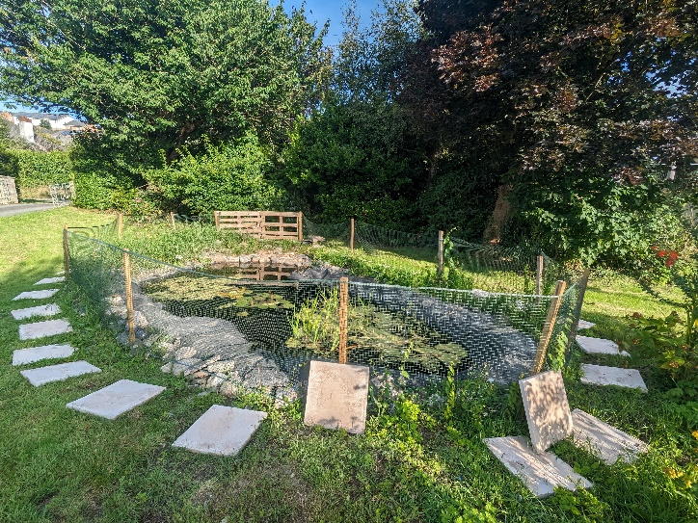
The garden now provides fresh produce for three local pay-as-you-feel community cafes in the area, as well as to volunteers. The garden has become a member of the National Garden Scheme and holds regular volunteer sessions and open days.
Nick has felt much more supported in his gardening efforts from the involvement of Tyfu Dyfi.
“I can’t thank you enough for your help with the funding for the garden. It has a made a real difference and allowed us to produce more food for the community than ever before.”

