Llandre Community Garden
Case Study
July 2023
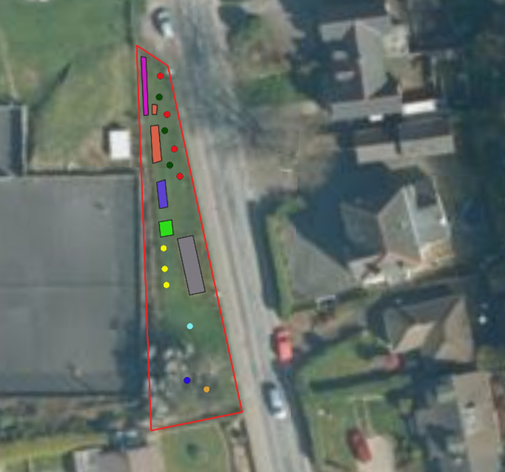
Set up in March 2021, this is a narrow strip of unfenced land running alongside the main road through Llandre, a village near Bow Street, Ceredigion. The land is owned by Ceredigion County Council and the site is managed as an amenity for local residents by a handful of volunteers.
The space is divided into three areas: a raised bed with fruiting shrubs and herbs, a tapering section towards one end which has been planted with fruit trees, and a grassed area which is managed for wildlife, and includes a park bench.
With this combination of lawn and raised bed the Garden aims to be a peaceful green space where people can use simple gardening skills to grow food and meet people.

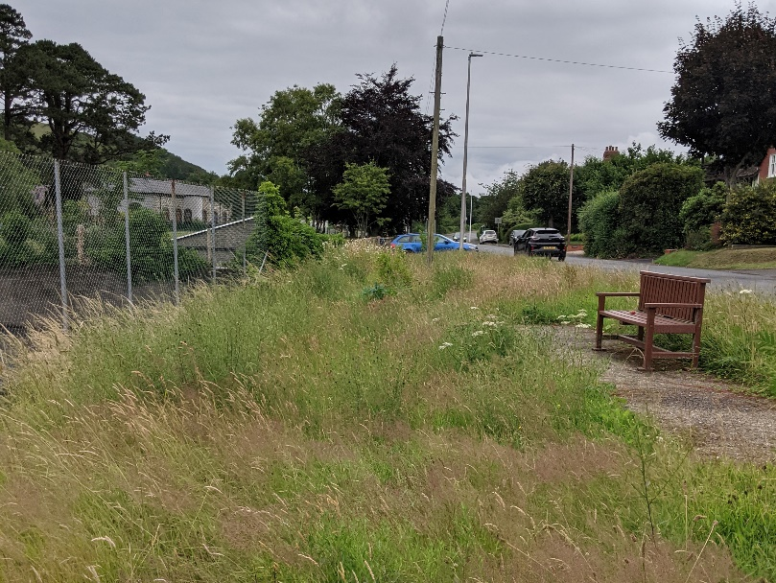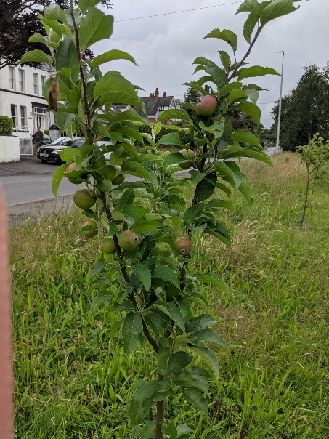
The volunteers put in a request for just two items: a system to harvest and store rainwater off a shed roof in an adjoining plot owned by the community council, and a wooden hand-carved signboard to identify it as a community garden. The total cost was £780.

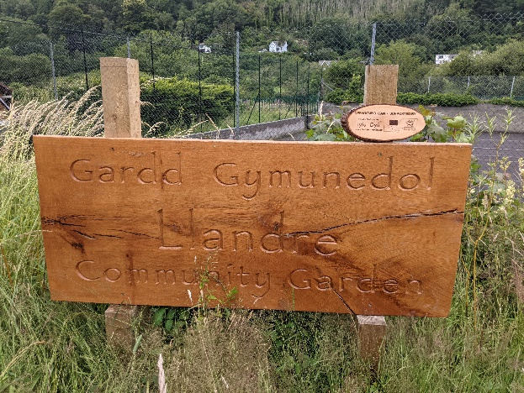 | 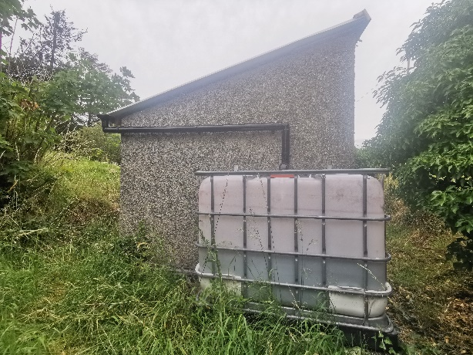

By June 2023 the works were complete and the garden was looking good. Mown paths take the visitor past apple trees, fruit bushes and grassland rich in wildflowers.
Although only a few volunteers maintain the site, they report that local residents regularly come and use the seat and walk through garden.
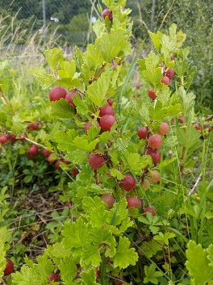
“A boy came into the garden the other day and took a strawberry. I pointed out the gooseberries – which he had never seen or heard of before - and invited him to taste one. He then ran home and came back with a plastic tub to collect more, and said they were going to cook them for tea” – Volunteer

They have further plans to construct a more formal garden with herbs and flowers at one end, and are talking to the County Council about other gardening opportunities in the village.

