Llanfach Hall Community Garden
Case Study
July 2023
Location: Llanfach Hall, Taliesin, Ceredigion
W3W: scoop.deprives.deep

Background:
In winter 2022/2023 Llanfach hall approached the local village, Taliesin, to see if anyone could make use of their garden space as it was not being used effectively by the hall. A small group of residents decided to try and develop the site into a community garden to benefit the village. The group secured support and funding from the village council to cover the costs of public liability insurance for the garden space. A public gardening event was held at the local café, Cletwr, in March 2023, in which speakers, including Huw Richards, helped to develop ideas for the garden space.

How has Tyfi Dyfi and Garden Organic supported the project/site:
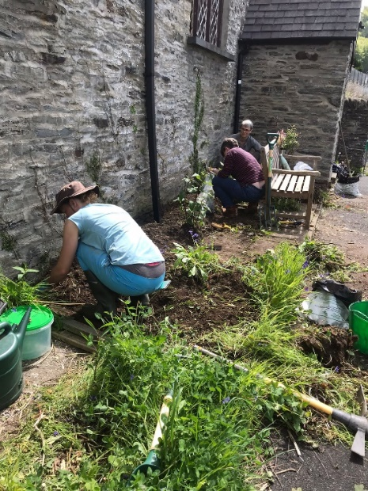
Tyfu Dyfi has provided approximately £3800 towards materials for the garden. This has gone towards purchasing new accessible planters, a polytunnel, materials for raised beds, steps and a fence, as well as plants to get the garden going.
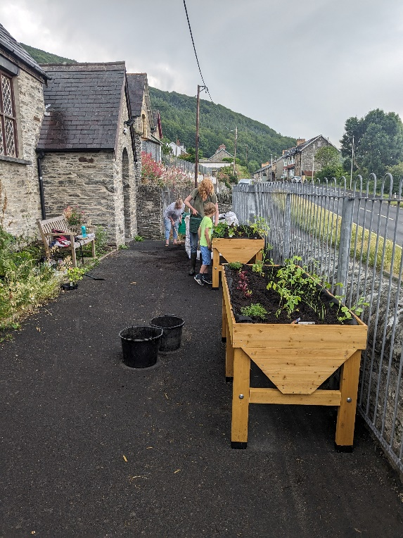
Before Tyfu Dyfi was involved the site was overgrown and unmaintained. The materials provided have allowed the volunteers to start growing vegetables and flowers. The project has only been going for a few months, but the individuals involved have already established a strong support network for garden and have set themselves up as a constituted group.

The project and individuals feel supported by the help from Tyfu Dyfi.

“We would not have had the confidence to push on with establishing the garden if it wasn’t for your help.”

