Penglais Community Garden
Case Study
July 2023
Hidden away between the Students Union and the Arts Centre on Penglais Campus, Aberystwyth University, this garden began as a student project in 2012 and then was taken over by staff in 2014. It is now run by a group of volunteers with regular work sessions for students, staff and local people, where people come to learn food growing. It occasionally produces a surplus of food for sale or donation to community meals, and it is a pleasant garden in which to sit and chat.
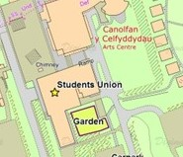
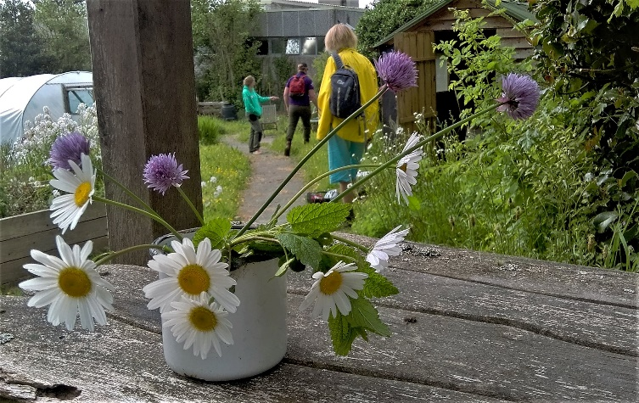
It includes raised beds, a seating area, a polytunnel, a composting area, a fruiting hedge and several wild areas.
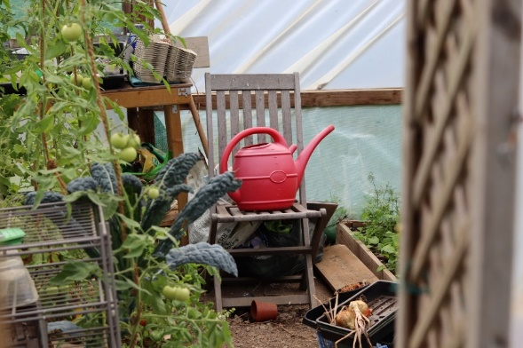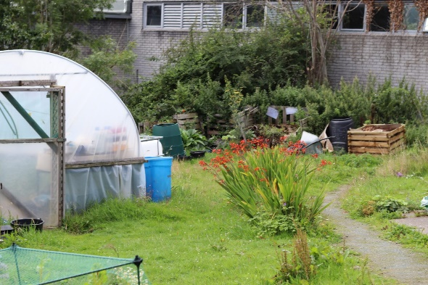

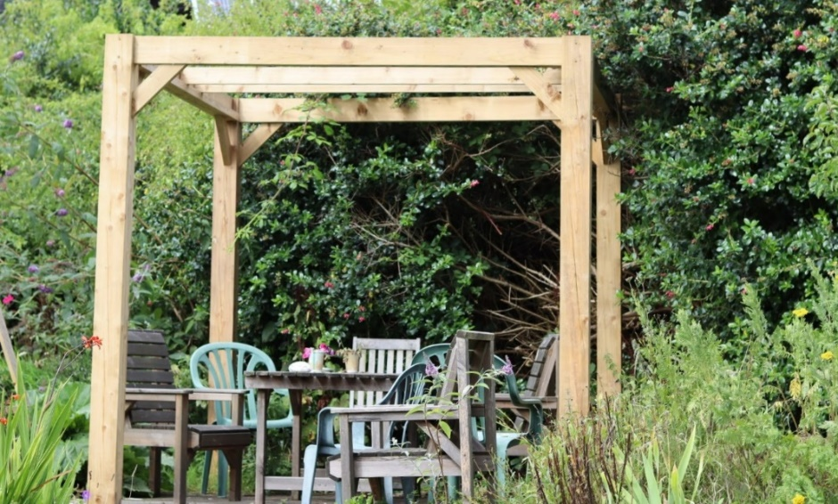
The committee requested a range of items costing a total of £1515. A major part of this was a pergola, table and chairs to improve the seating area, making it a more welcoming space. This is already getting regular use. In due course the pergola will support climbing plants.
Another was an IBC water container for the polytunnel, both to store water and to moderate the temperature. To provide habitat, they requested two barrels to sink into the ground as ponds.
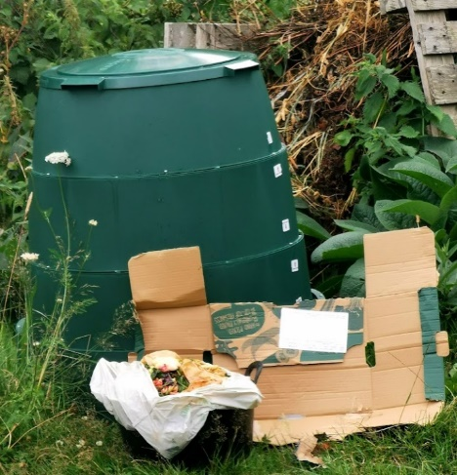
Another important purchase was two compost bins: a Green Johanna means that the garden can compost food waste from the Arts Centre café, and a plain wooden bin will be used to take coffee grounds and cardboard, both freely available from the cafes at the Arts Centre and the Students Union. These could be the basis of student volunteering projects in future.
Last but not least, a label printer means that they can keep track of what they have planted, and explain the garden to visitors.

“The funding has meant that we’ve been able to upgrade the garden on all fronts, making it more welcoming to visitors, and expanding what we can do – it’s given us quite a boost” – garden volunteer coordinator

