Penrhyn-coch Community Allotment
Case Study

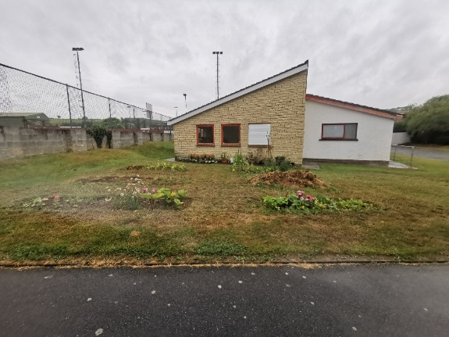
This garden is at the rear of Penrhyncoch Football Club in the village of Penrhyn-coch, six miles outside Aberystwyth. The land is owned by the County Council and is on a well-used footpath, quite close to the school, children’s play area and church.

It was started at the invitation of the Football Club in spring 2022 by two local residents, who dug six beds into the lawn in front of the pavilion and planted vegetables and flowers.

It is intended to be an attractive amenity, a habitat for wildlife, and a place to share food growing skills, but it didn’t look like much. Tyfu Dyfi funded various improvements to the site, at a total cost of around £1800, the main one being two L-shaped raised beds to form a boundary to the garden on the footpath side, linked by a pergola.

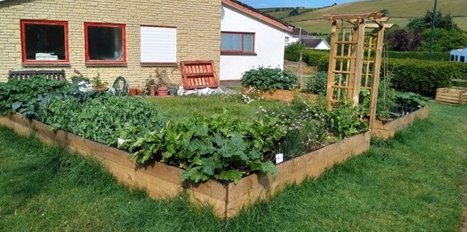

Tyfu Dyfi also paid for a compost bin, a water butt, a bench with storage and some tools. The beds were installed by Penparcau Community Forum, with help from volunteers including the football club’s groundsman, and the effect was instant.
Once the beds had been filled with topsoil and compost, and some plants put in, the two founding volunteers were soon joined by local residents. Some examples:
- a local child-minder regularly takes her children there for sessions
- a few local residents share the space informally, growing and harvesting the produce
- someone whose retired parents live in the village has planted tomatoes and climbing beans, so that they can see them on their daily walks
- the local primary school has visited to harvest potatoes and plans to contribute their own seedlings
- passers-by often stop for a chat, and to pick the odd pea-pod or salad leaf.
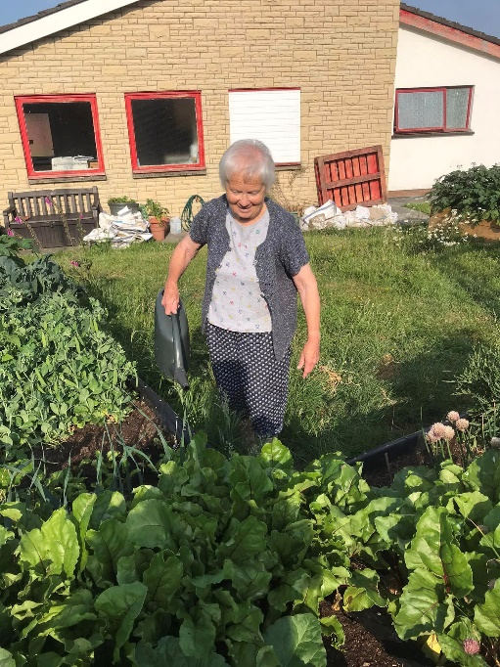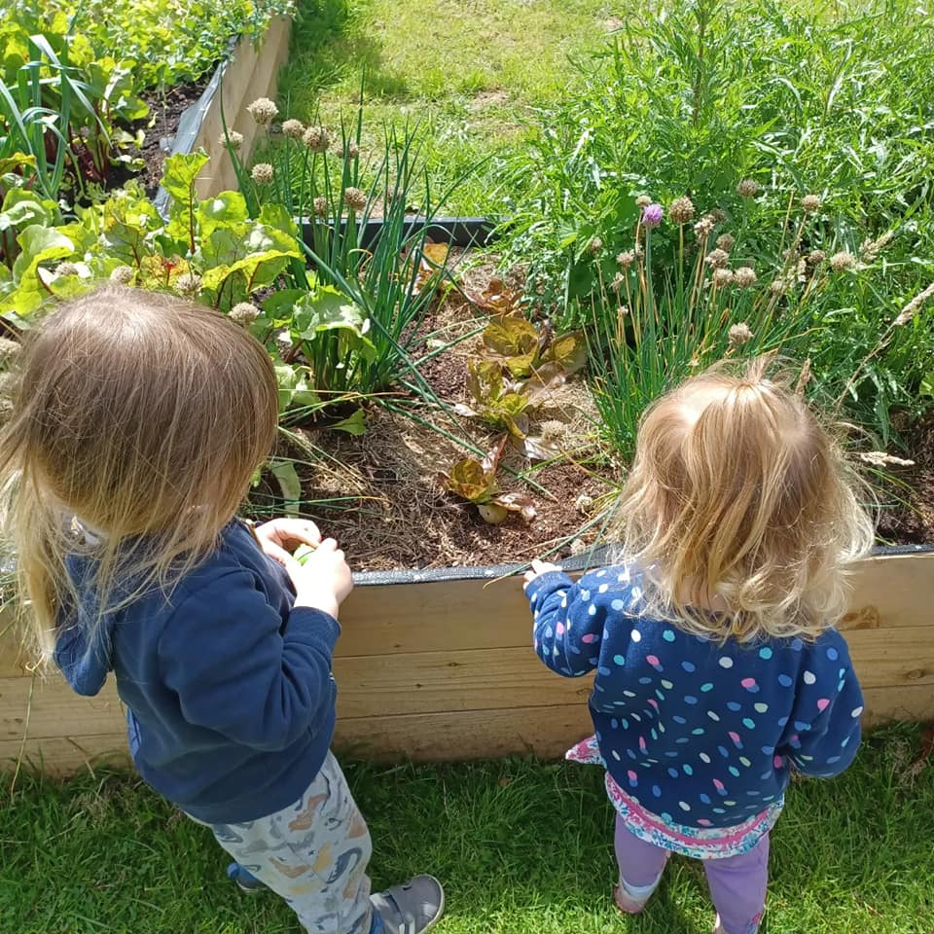

Some posts from the Facebook group:

“Thinned out and enjoyed some baby beetroot. Tender and delicious.
Not sure about purple potatoes though!”

“Veg beds looking very good with the warmer weather. Chard is ready for picking - best picked rather than let it go to seed. Got ours for tonight - sautéed with olive oil and garlic.”

“I am moving to Penrhyncoch on Monday and would love to come along to garden as my new garden is so much smaller than my previous one. Will there be room for fruit trees?”

