Aberystwyth WW2 Allotment
Case Study
July 2023
Location: Aberystwyth WW2 Allotment, Penglais Hill, Aberystwyth
W3W: soggy.crafted.hubcaps
Project contact: Sian Nicholas (shn@aber.ac.uk)

Background:
The allotment grew out of a National Lottery Heritage Fund project on WW2 - People's Voices in a People's War: Aberystwyth 1939-1945 - which ran from May 2020 to July 2022. Due to Covid, the project couldn't hold some of the face-to-face events so the 'make do and mend/wartime cookery' events were adapted to 'Digging for Victory'. The plot of land was secured from Aberystywth University Farm Estates in spring 2022, which was previously used for rough sheep grazing. The site was developed in accordance with the original WW2 Digging for Victory plan which was issued by the government at the time.

How has Tyfi Dyfi and Garden Organic supported the project/site:
Tyfu Dyfi has provided approximately £5700 worth of materials to the site. The largest purchase was for the building of a new rabbit proof fence around the allotment. Other significant items included a shed, benches, a large water container (IBC), as well as wheelbarrows and hand tools.
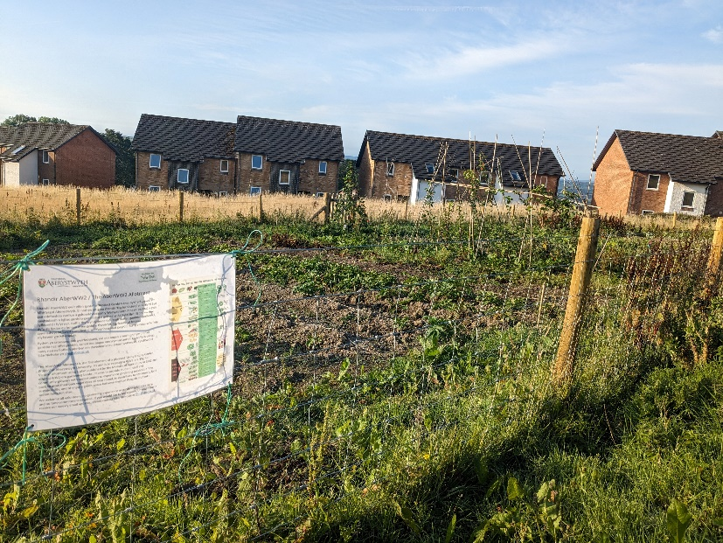
The site has benefited from the support of Garden Organic through participation in various events that we have helped to organise (Green Fair in September 2022, Big Dig in December 2022, Heritage Orchard planting March 2023, Seedling Swap in May 2023). The site has also been able to network with other local gardens (Penglais Community Garden) and community initiatives (St Pauls Methodist Church pay-as-you-feel café, Aber Food Surplus) to distribute their excess vegetables.
Sian has felt support and encourage through our involvement over the last year, especially so when bureaucratic hurdles were hit, and when the rabbits kept getting through the fence!

